

St Robert’s Catholic Primary School
Ysgol Gynradd Gatholig Sant Robert

School Prospectus 2023-24

Headteacher’s Welcome
Thank you for taking the time to find out about St. Robert’s Primary. We are very proud of all the exciting learning that happens at our school.

We are a Catholic school in the Archdiocese of Cardiff, therefore all we do is rooted in Gospel values. Our children learn to value and respect themselves and others through Christ’s example and to enjoy life to its full.

The school currently has 175 on roll. This number ensures that the school has a ‘family’ feel to it and enables all children to build excellent relationships with one another, as well as with staff.

The school has beautiful grounds, which allow the children to play and learn outside,
enjoying and appreciating the natural world.

The school has strong ties to the parish community which enables our children to belong to a wider supportive faith community.

At St Robert’s, we feel that children thrive most when supported and challenged. Our
staff have high expectations for all children to achieve their very best in all areas of learning. This
is through a highly engaging curriculum.

We recognise that a strong bond between home and school is essential for children to enjoy school and achieve success. We hold regular events for you and your family to visit the school and share in your child’s milestone achievements.

As a Headteacher, I feel privileged to be able to lead St Robert’s Catholic Primary School
and I very much look forward to meeting you and showing you our school so that
you can feel and see all that is mentioned above.

To make an appointment, please telephone 01656 815515 or admin@strobertscps.bridgend.cymru

Yours sincerely

Carmen Beveridge (Mrs.)
Headteacher

  St Robert’s Catholic Primary Mission Statement 

“The aim of the catholic school is The Christian growth of the children, not simply their growth in their own faith but a growing awareness of the world as a maturing Christian” (Bishop Conferences of England and Wales Catholic Education Council)

As a Catholic school community, we work together to provide our children with a high-quality education through a curriculum and environment which has Gospel Values at its heart. The ethos of the school is founded on Gospel values, which mean that we live by the teachings of Jesus and the example He set for us. This is summed up by our mission statement:

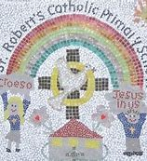

Mission Statement – ‘Jesus in Us’

Jesus and the ‘Good News’ that He brings is the basis of our school life.

Each person in our school is unique and our intention is that they will be Ambitious, Capable Learners; Ethically, Informed Citizens; Enterprising, Creative Contributors & Healthy, Confident Individuals.
They will be Virtue-led and develop to their full potential - with Jesus as their guide, the Holy Spirit as their inspiration and God as their loving Father.

We aim to ensure that each child: -
• lives out the Gospel message in their daily lives and develops the qualities of the eight pairs of
Virtues contained in our Catholic Pupil Profile.
• learns through a curriculum underpinned by the four core purposes
• enjoys learning
• fulfils his/her learning potential
• acquires knowledge and develops powers of reasoning
• receives the highest quality of education
• develops personal, social and moral qualities to make sound judgements, so that he/she can make
a positive contribution to society
We aim to develop in the children: -
• a love and knowledge of their Faith
• an appreciation that good manners and consideration for others are valuable qualities
• a love of reading and writing
• knowledge and understanding of mathematics and the development of appropriate language
• scientific curiosity and the ability to develop observational skills
• in using the Welsh Language and to experience the Welsh heritage that surrounds them through investigation of historical and geographical skills
• an awareness of their role in sustainable development and global citizenship and enjoyment of
physical activities, drama and movement, as well as basic recreational games and skills
• an appreciation of the Arts
• the skills to use technology appropriately
• the ability to be independent learners
• an appreciation for a healthy lifestyle

We aim for an open, friendly and professional relationship with parents where they can be involved
in the education of their children and the development of home, school and parish links, which
support the educational process. We invite all parents to co-operate with us in our work
for the spiritual, intellectual, moral, and physical development of their children.

The Catholic Pupil Profile at St. Robert’s Catholic School

St Robert’s support the development of the whole child through the adoption of the Jesuit Pupil Profile, as directed by the Archdiocese of Cardiff. The Pupil Profile is composed of 8 pairs of virtues that sum up how pupils and staff in our Catholic Schools should be living and learning. This is in keeping with St Ignatius Loyola’s own vision that we can show
“...improvement in living and learning for the greater glory of God and the common good.”
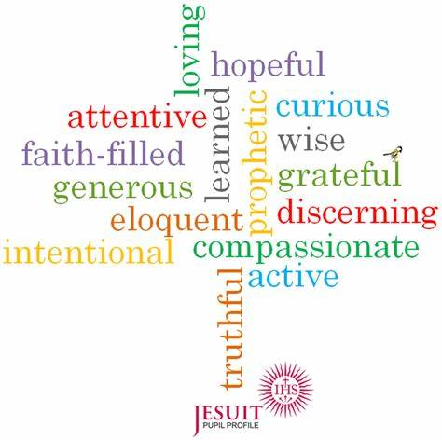
The Pairs of Virtues are-
- Grateful & Generous
- Attentive & Discerning
- Compassionate & Loving
- Faith filled & Hopeful
- Eloquent & Truthful
- Learned & Wise
- Curious & Active
- Intentional & Prophetic

❖ Grateful for their own gifts, for the gift of other people, and for the blessings of each day; and
generous with their gifts, now and in the future.
❖ Attentive to their experience and to their vocation; and discerning about the choices they make and the effects of those choices.
❖ Compassionate towards others, near and far, especially the less fortunate; and loving by their just
actions and forgiving words.
❖ Faith-filled in their beliefs and hopeful for the future.
❖ Eloquent and truthful in what they say of themselves, the relations between people, and the world.
❖ Learned, finding God in all things; and wise in the ways they use their learning for the common good.
❖ Curious about everything; and active in their engagement with the world, changing what they can
for the better.
❖ Intentional in the way they live and use the resources of the earth, guided by conscience; and
prophetic in the example they set to others.

School History

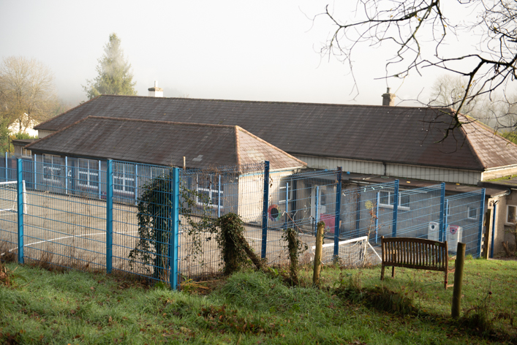

St. Robert's School was built on its current site in 1927 although the Church has had a school in the area since 1879. It became a primary school in 1964 when Archbishop McGrath Comprehensive School was opened. It serves a wide catchment area that includes the Ogmore and Garw Valleys. About 90% of the pupils travel to school by public or private transport. The main building is made of stone. During early 1992 two demountable classrooms and extra toilets were added to the site to provide much needed infant areas for the school’s growing numbers. The school has had a new multi-purpose hall installed in 2000 and all buildings are covered by security lighting and alarms. Lots of development has taken place on the school grounds to establish an outside learning classroom, this has provided an excellent environment for many lessons and school activities.
School Organisation
St Robert’s Catholic Primary School is a voluntary aided day school, established under the trusteeship of the Roman Catholic Archdiocese of Cardiff. Bridgend County Borough Council is the local authority that maintains the School. St Robert’s is designated a Primary School, that is for rising 5-year-old pupils to pupils of 11 years, and is co-educational. We also provide non statutory nursery provision for rising 4-year-old pupils.

Staff of the School (Sept 22)
Headteacher: Mrs C. Beveridge
Deputy Headteacher: Mrs B. Murphy

Foundation Phase Teachers
Mrs E. Neill
Miss K. Holder
Mrs S. Taylor
Learning Support Officers Foundation Phase
Miss J. Robbins
Miss B. Mordaunt

Key Stage 2 Teachers
Miss B. Petty
Mrs S. Lewis
Miss R. Rossi
Mrs B. Murphy
Learning Support Officers Key Stage 2
Mrs J. Kilminster
Mrs K. Sadd
Mrs T. Clarke

Senior Support Officers
Mrs S-D. Tucker (Part time)
Ms S. Reynolds
Family Engagement Officer
Mrs S-D. Tucker (Part time)

Non-Teaching Staff
Mrs J. Daly - School Administrator
Mr S. Ralph - Caretaker

Lunchtime Supervisory Assistants
Mrs K. Sadd, Mrs M Peruga, Mrs R. Collins & Mrs V. Cook

Cook in Charge
Mrs D. Morgan

Governors of St. Robert’s Catholic Primary School
The Chairperson of our governing body is Ms Susan Reynolds. The Vice-Chair is Mr Brian Davies. Our governors are like a Board of Directors and they make decisions about how the school is managed. They meet at least once a term at school and a range of sub-committees meet regularly. They are the employers in a Voluntary Aided school and they control the admissions process.

Communication from School
There is a regular newsletter telling of school news and future dates to note. Individual letters go out separately regarding other matters such as school trips for example. We operate Class Dojo which is proving to be an effective way of communication between school and parents.
Our website includes a range of useful information about the school at www.strobertscath.co.uk archive newsletters are available there.
Parents receive full written reports for their children annually in the Summer Term.

Social Media

We have a presence on social media through X.
Please follow us:
@strobertsrc

and Facebook:
https://www.facebook.com/profile.php?id=61550648147692

Communication to School
If your child is absent the school would expect to receive a Dojo message to your child’s class teacher or a ‘phone message by 9.30 am, school office telephone number: 01656815515
If we do not hear from you, we will contact you directly in the interest of the child’s safety.
Where there are specific problems in the home, which you feel might impact on your child in school, please inform us. We will do everything we can to help and support parents and families in difficulties.

School Hours
Children are supervised in the yard from 8.45 am onwards. Children who arrive before this time are not directly supervised, however the school offers a free Breakfast Club, funded by the Welsh Government and parents are encouraged to use this service. The vast majority of children at St. Robert’s arrive by coach; I would ask all parents who transport their children to school to be punctual. School starts at 8.55 am.

Starting and Finishing Times
Morning.
08.45 Pupils should arrive in the school yard ready for the bell.

08.55 School session starts.

10.15-10.30 Foundation Phase Morning Break

10.30 - 10.45 KS 2 Morning Break.

11.45 - 13.00 Lunch Break – Foundation Phase

12.00 - 13.00 Lunch Break KS2.

Afternoon.
13.00 School session starts

15.25 School finishes.

After school finishes it is the parent's duty to ensure that their children are collected from school on time. All children who travel home by bus are escorted to the coach by staff/ escort. Parents collecting children by car should park in the car park off Pen-y-Fai Road.

Also, parents must wait outside the school gates for their children – this alleviates congestion in the school yard so that staff are able to line up the children who go home by bus.
If your child is going home with someone other than parent/guardian/carer, it is essential school is informed IN WRITING of this change. If it is an emergency a telephone call will be acceptable. We will not allow a child to go with another person unless we have been informed.

Class Structure
Due to varying numbers in each year group, all or some classes may have mixed age pupils. Decisions about the appropriate placement of children is given consideration by the Headteacher and staff, and where pupils are placed in classes aside to their normal age group, factors such as: attendance, maturity, social skills, siblings are considered as well as ability.
All classes, even single age classes, contain a wide range of abilities and have children with different learning styles and needs. Our experienced staff use a range of effective teaching techniques to cater for the needs of all pupils in their class, in order for all the children to achieve their full potential.

Safety in our School
Parental support in ensuring all our children are kept safe is vital. Therefore, it is necessary to note the following regulations: -

- School Entry – The main door system is designed for Security measures. Please press the buzzer and wait for the door to be released. Please be patient.
- No car is permitted to be driven onto the school premises when presenting or collecting your child.
- This also applies to after-school functions such as children's discos or concerts.
- No dogs are allowed on the school premises. The health and safety of our children is very important and dogs fouling the grounds would provide an unnecessary danger.
- If your child has long hair, this should be tied back in school. During the day your child may be involved in science, PE or technology tasks where loose hair falling forward may be hazardous. Your support in this matter would help your child understand the importance of safety in many varied situations.
Child Protection/Safeguarding
The protection and wellbeing of all pupils is a priority of this School.
The Headteacher has overall responsibility for child protection matters and acts as a source of advice and support to other school staff.
Our school also has a nominated Child Protection Governor, who has to ensure that the School has a Child Protection Policy in place which is consistent with the All Wales Child Protection Procedures (2002), which all staff in the School must follow where there are concerns or suspicions or child abuse.
If we receive information about a child which suggest that he/she has been abused or at risk of being abused, we have a duty to refer these concerns to the social services dept, or the police without delay. We have no discretion in this matter.
Our first concern as a school is your child’s welfare and where we have general concerns these will be raised with you and we would want to work with you to remedy the situation. However, there may be concerns, as listed above, where we have to talk to other agencies before we contact you. Should this be necessary, we want to reassure you that any concerns we have about your child will then be fully discussed with you in a way which is consistent with your child’s best interest.

Attendance
Your support in ensuring that attendance is regular and punctual is vital and much appreciated.
Children, who are not attending the Breakfast Club, need to arrive at school for 8.45 - 8.55am. They will be supervised by staff after 8.45am. Persistent lateness disrupts not only your child’s learning but also that of his/her peers therefore, your punctuality is much appreciated. If you are late, please report to Reception.
If your child is absent, you should inform the school on the first morning of the absence before 9.30am. We will contact you if you do not do this, in order to ensure that your child is safe.
Children who have medical appointments – dental, optician, hospital visits – should attend school before or after the appointment if possible. Holidays in term time are strongly discouraged. They will only be authorised according to exemptions given in Welsh Government guidance. We work closely with our EWO who monitors attendance closely. Parents whose children’s attendance gives any cause for concern will be contacted directly.
Sickness and Accidents
If your child is unwell in school and the Class teacher feels he/she should be home you will be contacted. It is very important that you give your works number (if you work) or indeed emergency numbers in this event and update regularly.

If your child has an accident in school and the First Aider or class teacher / Headteacher feels that the child should need medical attention you will be informed. If your child has a head injury however small you will be notified.

The school will do all in their power to contact you i.e. leaving messages on answer phones or emergency numbers.

Pupil Health and Wellbeing
It is vital that children who show symptoms of being unwell should not be sent to school. They will be unable to concentrate on their learning and could pass on their illness to others. In cases of infectious diseases such as Chicken Pox, Measles, German Measles, Whooping Cough and Mumps etc., the school must be informed immediately.

Medicines
Medicines will be administered. However, the following criteria must be followed:
- Only prescription medicines will be given
- You must sign a School Medicine Form. This is available from the class teacher or the school website.
- All medicines must always be in the correct bottle with child’s name and instructions on administration/dosage.
- All medicines must be given to the class teacher or in her absence the Headteacher.
- Epi-pens must be clearly labelled and replaced in good time prior to reaching expiry dates.
- Asthma pumps should be accessible to the child. This should be the ‘reliever’ pump and not the preventative steroid pump which is not appropriate for school. Relievers are usually blue and do exactly that; relieve symptoms of asthma when a child is wheezy or breathless. Please ensure any spacers are also included with the pump and that your child is familiar with its use. All children’s pumps are kept in the classroom and must be replaced in good time prior to reaching expiry dates.
- Children with chronic illnesses that require medication will be supported. All staff at St. Robert’s are sympathetic to this and will do all in their power to give help.
- The school will not be held responsible for any maladministration of medicines.

Health Checks
A number of medicals take place during the primary phase for all children. These involve checks on children’s hearing, sight and teeth. All medicals are arranged by the local area health authority.
Parent’s attendance at school medicals is not required.
All medicals are strictly confidential.

School Transport
Free transport is available from the Garw Valley, the Ogmore Valley, Tondu, Coytrahen and other areas more than 2 miles from the school.
Parents are asked to talk to their children and make them realise the importance of good behaviour on buses. There is an escort on each bus. A list of stops is available from Bridgend County Borough Council.
Any issues relating to school transport can be directed to:

School Transport
Bridgend County Borough Council
Angel St
Bridgend
Telephone: 01656 643643
Email: schooltransport@bridgend.gov.uk
For children whose behaviour is constantly unacceptable:
(i)parents will be notified by letter from the LA
(ii)if in the opinion of the Education Office they constitute a danger then you will be responsible for transporting your own child/children to school.

Consultation with Parents
Autumn Term: Virtual or face to face consultations - parental preference
Spring Term: Virtual or face to face consultations - parental preference
Summer Term: Proud to Present - the pupils and parents review the year’s work together and parents receive their child’s End of Year Report.
Consultations between parents and teachers are an important part of the school year. It is a time for
parents and teachers to meet in a circumstance of mutual interest in the child’s development and welfare, to consult on matters of behaviour, progress and attitudes. Any pastoral matters may be discussed at this time however it may be necessary to make a further appointment in order to allow for more time.
Each pupil’s progress is carefully monitored and assessed throughout the year. Parent/teacher
consultations are arranged out of school hours and parents are notified regarding appointment times.
Parents are welcome to class and school events eg meet the teacher, Learner Forums, Parental Workshops, Masses, Christmas concerts, sports day, Summer productions etc. These give parents the opportunity to join our school community and find more out about the education that their children are receiving.
The school has an open-door policy and parents are invited to contact the child’s class teacher / Headteacher at any time if they are concerned about any aspect of their child's education or welfare. Then an appointment can be made to discuss the situation in more detail.

Homework
Children will be given homework on a regular basis as and when appropriate to their needs. In the early years especially, reading with your child daily is very important. In the later years children should still be reading regularly to an adult at home and completing their reading records. These records need to be signed by parents everytime a child reads to them (at least three times a week).
Parents are encouraged to help children learn their tables, tell the time, play board games etc. In fact any worthwhile experiences e.g. cooking, shopping, helping at home will help widen children's horizons and develop their talents.

Free School Milk
This is available for all pupils in the Foundation Phase.
School Meals
The school meals are provided by BCBC Catering Services. Meals are healthy and well balanced. They are eaten in the hall. Pupils are always supervised either by Lunchtime Supervisors or school staff. Prices vary from year to year. More information is available from the school secretary. The school operates a cashless, on-line payment system.
Phased Rollout of Universal Primary Free School Meals For The Youngest Children From September 2022 Onwards.
From the new Autumn term 3 September 2022, onwards, the majority of Reception children will be
offered Free School Meals. This is an important step in reaching the shared ambition of ensuring no child goes hungry while in school. In response to the current rising cost-of-living, Welsh Government and BCBC are committed to implementing this scheme quickly and would ask for your patience as we build catering capacity to ensure a successful phased implementation and work towards a whole school rollout over the next three years. BCBC are working with the Welsh Government to develop a process for you to be able to request a free meal for your child/children in Reception from September, trying to avoid any unnecessary burden for you. Further information will follow by the end of term. Please rest assured that if your child is currently in receipt of free school meals and/or any other associated benefits, these will not be affected.
Packed Lunches
Please make these nutritious and balanced. Please help us by providing a balanced healthy lunch for your child.

Break Times Snacks & Drinks
We encourage children to bring a fruit snack for their morning break to encourage healthy eating. Sweets, crisps, or chocolate are not permitted. Every child should be provided with a water bottle. We ask that parents fill it for them daily and that the bottle is washed every evening. Children can top up their bottles during the day.

School Uniform
There is an official school uniform of royal blue, grey and white. Stud earrings only may be worn. Bracelets and necklaces are not allowed because of the risk of accidents. A sensible watch is acceptable.
Royal blue sweater, cardigan - no hoodies please.
Grey /black trousers, skirt or pinafore dress.
White or pale blue polo shirt.
Summer wear - grey/ black shorts or blue and white checked dresses.
Footwear - suitable and appropriate black school shoes should be worn at all times. Shoes with high heels are not deemed suitable.
Only Foundation Phases Classes (Mrs. Neill’s, Miss Holder’s and Mrs. Taylor’s classes) wear blue tracksuit/joggers and trainers to school on their P.E days. Other than P.E. days, the pupils are requested to wear the school uniform.
Children need to be dressed in school uniform for all school days. Nail varnish / stick on tattoos/exotic hair colours or styles are not appropriate for school days - please keep these activities for weekends and school holidays. Thank you.
We do encourage children to take care of their appearance and to dress neatly in uniform. It is important that children have a change of clothes for P.E. The P.E. Kit consists of - black shorts, school P.E. T shirt with child’s house embroidered on it. Appropriate footwear will also be needed. Please ensure all clothing is labelled with your child’s name. This enables us to recover ‘lost’ items easily.

The Curriculum
The Curriculum is the interaction between the teacher and the learner and, as such, transmits attitudes and values, in addition to knowledge, skills and understanding. High standards are created through high expectations, which are at the core of the attitudes and values we transmit through our curriculum delivery. The Gospel values permeate everything we do.
The principles underlying our Curriculum are as follows:
- It is distinctively Catholic and virtue-led;
- Has the development of the Four Purposes with pupils at its centre;
- Is committed to the success of every learner regardless of background and personal circumstances;
- Develops an inclusive school that focuses on the wellbeing, excellence and equity of all our learners;
- Is broad and balanced, and is based on the six Areas of Learning and Experience;
- Is knowledge-rich, develops skills progressively and provides pupils with a wide range of experiences;
- Is committed to providing pupils with high quality teaching and learning across all areas;
- Is an enquiry-based approach that cultivates pupils curiosity and allows them to engage with meaningful and authentic contexts;
- Develops pupils literacy and numeracy skills and digital competency;
- Informs pupils about the world including the local, national and international perspectives.
At St Robert’s, children are given the opportunity to become:
- ambitious, capable learners, ready to learn throughout their lives and achieve to their full
potential.
- enterprising, creative contributors, ready to play a full part in life and work, drawing on their resourcefulness.
- ethical, informed citizens, ready to be citizens of Wales and its world with a secure
understanding of their culture and heritage.
- healthy, confident individuals, ready to lead fulfilling lives as valued members of society with a knowledge of mental and physical wellbeing.


Areas of Learning and Experience (AoLEs)
We break the curriculum into the following Areas of Learning -
Religious Education
Catholic children receive their initial knowledge of the Faith from their parents who are their first and most important teachers. As the children grow older, the parish community, and later the school, support the parents and share in that process by which children are brought to a greater understanding of the meaning of their Baptism and the mission of the Church.
In school, religious education is taught through regular lessons, the seasons of the Church's year, various liturgies, assemblies and, not least, by the attempt to create a school ethos which reflects the values of the gospel. The school realises its role in evangelisation and also supports parish catechesis. The Sacraments of Reconciliation and Eucharist are prepared in school, the children are in Y3 or above.

We follow the RE Directory for our learning in RE. We aim to encourage our children to learn about the Catholic faith and to reflect on ways to put it into practice for the good of others. We also study other major world faiths and we encourage respect for them all.

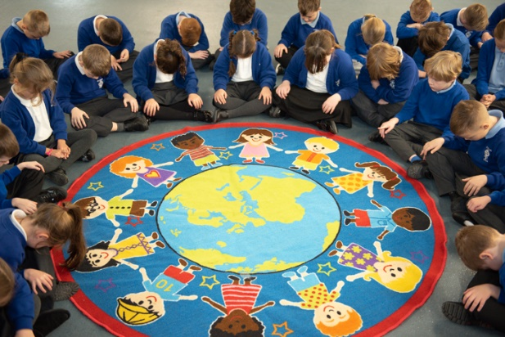
Collective Worship
Principles of Collective Worship
All Acts of Worship in St. Robert’s will:
- Give praise and honour to God
- Give children positive liturgical experiences
- Include a range of experiences offered in a variety of groupings and settings.
The format for Collective Worship in our school
Gather - how we come together.
Listen - to scripture from the Old or New Testaments.
Response - response to the Word may lead into a time of ritual action or prayer.
Going Forth - a mission or message for the pupils to take beyond the act of worship

Collective worship takes place in a variety of ways.
Daily worship through prayers and reflection occur. The whole school share worship weekly which has been prepared by a specific class or led by a staff member.
Regular Masses, Reconciliation services and other Para liturgies form the basis of joyful celebrations. Parents and our parish community are invited to join us for Masses and services.
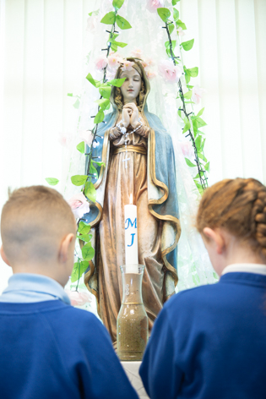
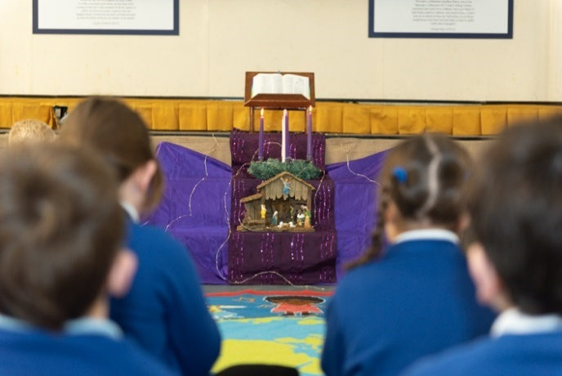

Language Literacy and Communication (including Welsh and international Foreign Language).
Based on the Curriculum for Wales, our Literacy curriculum ensures that pupils are given opportunities to experience a wide variety of activities to enhance their understanding and knowledge in this area. Learning is focused on the four ‘What Matters’ statements in the LLC area of the curriculum.
- Languages connect us.
- Understanding languages is the key to understanding the world around us.
- Expressing ourselves through languages is the key to communication.
- Literacy fires imagination and inspires creativity.

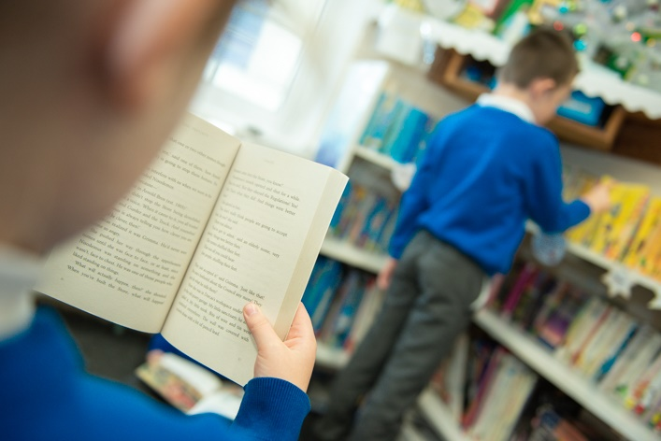
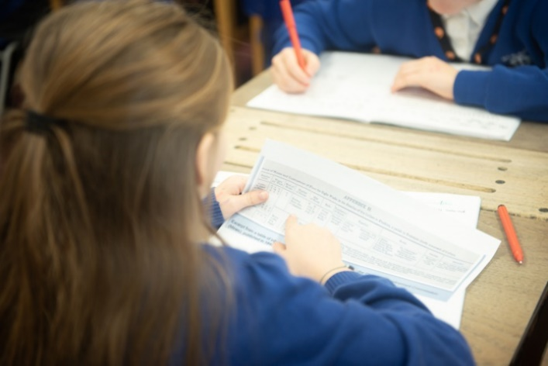

Welsh
At St Robert’s, Welsh is taught as a second language with incidental Welsh being used daily. We aim to foster a Welsh ethos and promote enjoyment of the language. The children take part in daily Helpwr Heddiw sessions that reinforce vocabulary and sentence patterns through games and songs. The children at St Robert’s follow a CSC Scheme of Work designed to meet the requirements of the curriculum and the needs of the children.
Pupils lead role in promoting Welsh language and culture through our ‘Criw Cymraeg’. The school successfully achieved the Bronze award for Cymraeg Campus in November ‘22.
We aim to develop a sound understanding of our Welsh Culture. We hold an annual whole school Eisteddfod, activities include Welsh dancing, poetry, songs and the Crowning of our Bard.
Pupils compete in creative writing, art & handwriting. With the winners from each class achieving points for their house and the winning house is award the “Eisteddfod Shield”.

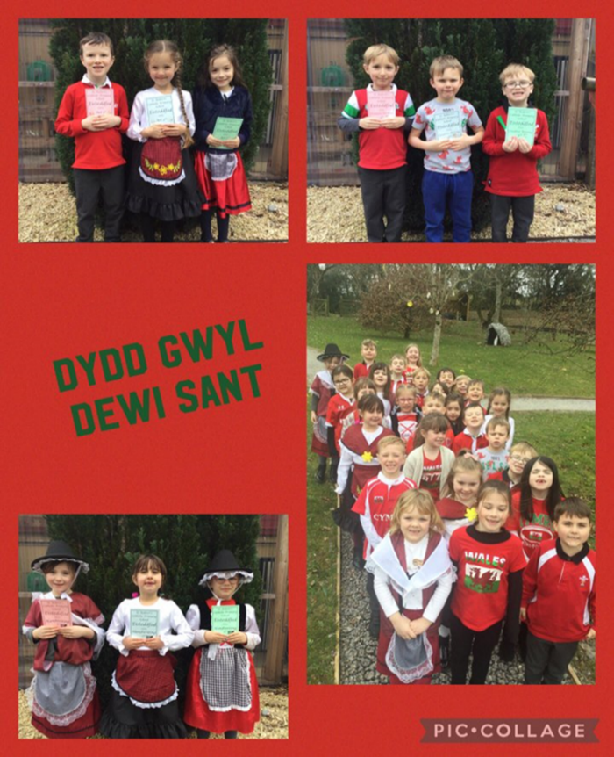
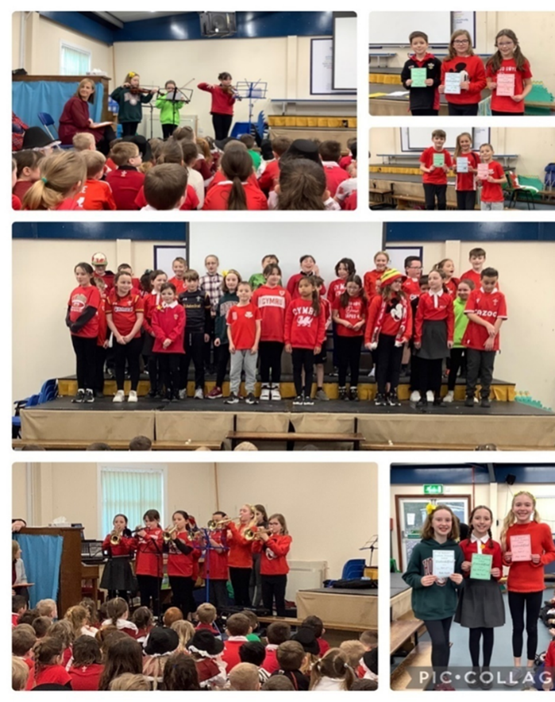

We ensure that the children develop an understanding of “Cynefin” meaning “the place where we feel we belong”. Teaching Cynefin is particularly relevant in the area of Humanities, which encompasses geography, history, religion, values and ethics and business studies.
Learning about Cynefin not only allows pupils to develop a strong sense of their own identity and well-being, but to develop an understanding of others’ identities and make connections with people, places and histories elsewhere in Wales and across the wider world. Local, national and global contexts are all important in this Area.

Mathematics and Numeracy
Mathematics surrounds us and underpins so many aspects of our daily lives, such as architecture, art, music, money and engineering. It is also essential for progress in other areas of learning and experience. Also, numeracy - the application of mathematics to solve problems in real-world contexts - plays a critical part in our everyday lives, and in the economic health of the nation. It is imperative, therefore, that mathematics and numeracy experiences are as engaging, exciting and accessible as possible for learners, and that these experiences are geared towards ensuring that learners develop mathematical resilience.
The focus within this AoLE is on
- The number system is used to represent and compare relationships between numbers and quantities.
- Algebra uses symbol systems to express the structure of mathematical relationships.
- Geometry focuses on relationships involving shape, space and position, and measurement focuses on quantifying phenomena in the physical world.
- Statistics represent data, probability models’ chance, and both support informed inferences and decisions.

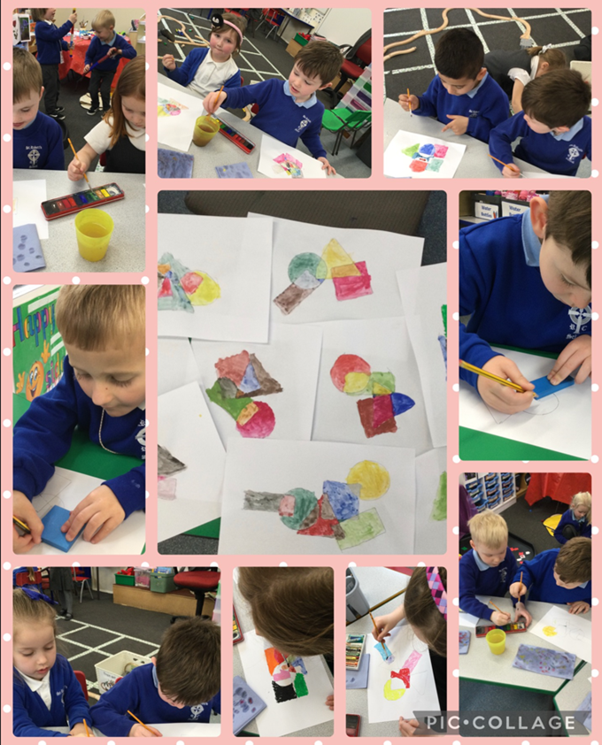

Expressive Arts
The dynamic nature of Expressive Arts engages, motivates and encourages our learners to develop their creative, artistic and performance skills. The Expressive Arts Area spans five disciplines, which are, art, dance, drama, film and digital media and music. The underlying elements include
- Developing artistic skills and knowledge and it enables learners to become curious and creative individuals.
- Responding and reflecting, both as artist and audience, is a fundamental part of learning in the expressive arts.
- Creating combines skills and knowledge, drawing on the senses, inspiration and imagination.

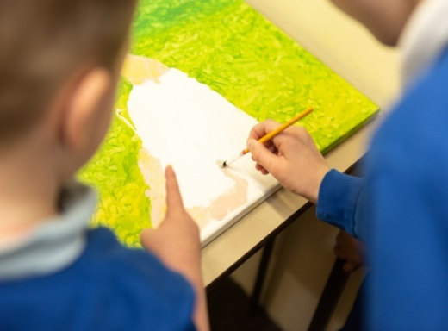

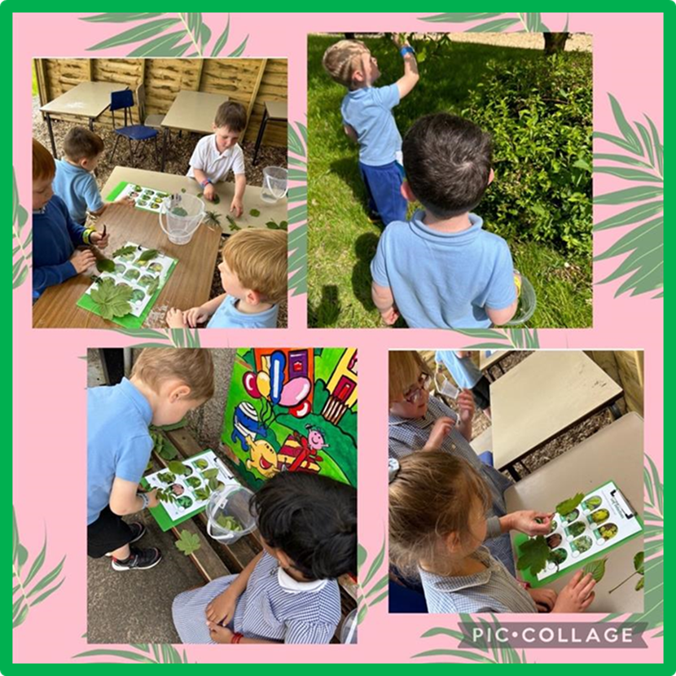

Humanities
Humanities encompasses geography; history; religion, values, and ethics; business studies and social studies. These disciplines share many common themes, concepts, and transferable skills, while having their own discrete body of knowledge and skills.
The pupils find out about the world we live in both a geographical and historical sense. The focus in this AoLE includes
- Enquiry, exploration and investigation inspire curiosity about the world, its past, present and future.
- Events and human experiences are complex, and are perceived, interpreted and represented in different ways.
- Our natural world is diverse and dynamic, influenced by processes and human actions.
- Human societies are complex and diverse, and shaped by human actions and beliefs.
- Informed, self-aware citizens engage with the challenges and opportunities that face humanity, and are able to take considered and ethical action.
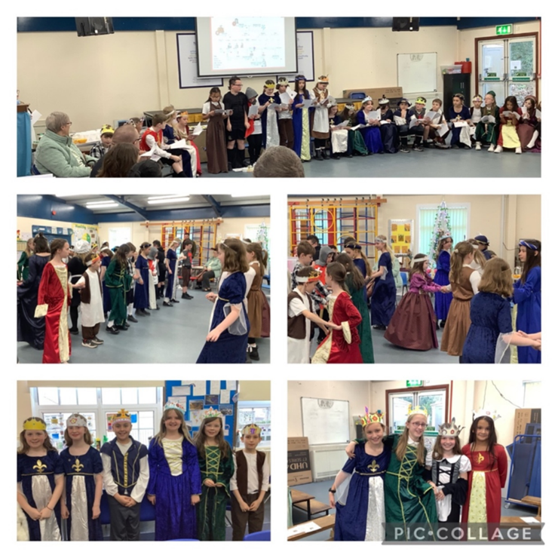


Health and Well-Being
The Health and Well-being Area of Learning and Experience provides a holistic structure for understanding health and well-being.
It is concerned with developing the capacity of learners to navigate life's opportunities and challenges.
The fundamental components of this Area are:
- Developing physical health and well-being has lifelong benefits.
- How we process and respond to our experiences affects our mental health and emotional well-being.
- Our decision-making impacts on the quality of our lives and the lives of others.
- How we engage with social influences shapes who we are and affects our health and well-being.
- Healthy relationships are fundamental to our well-being.
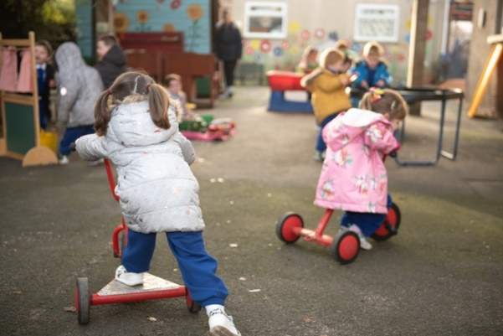
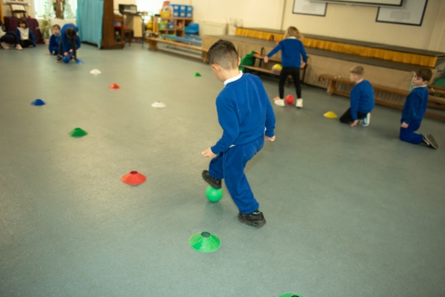

Science & Technology
The importance of science and technology in our modern world cannot be overstated. Developments in these areas have always been drivers of change in society, underpinning innovation and impacting on everyone’s lives economically, culturally and environmentally. As such, the Science and Technology Area of Learning and Experience will be increasingly relevant in the opportunities young people encounter and the life choices that they make.
The components consist of:
- Being curious and searching for answers is essential to understanding and predicting phenomena.
- Design thinking and engineering offer technical and creative ways to meet society’s needs and wants.
- The world around us is full of living things which depend on each other for survival.
- Matter and the way it behaves defines our universe and shapes our lives.
- Forces and energy provide a foundation for understanding our universe.
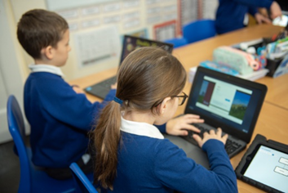
- Computation is the foundation for our digital world.


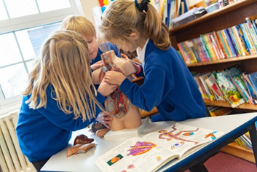

Relationship and Sexuality Education (RSE)
Relationships and Sexuality Education is developed through our Health and Wellbeing AoLE and Religious Education. We use two schemes to ensure the children have wide experiences in this area- Fertile Heart & Life to the Full (both are Archdiocese of Cardiff recommended schemes/resources).
Our curriculum will allow all children to develop the cross-curricular skills of literacy, numeracy, and digital competence. This encompasses the statutory Literacy and Numeracy Framework (LNF) and the Digital Competency Framework (DCF).
The school curriculum encompasses the mandatory requirements of teaching Welsh, English, Careers and Work-Related Experiences (CWRE) and Relationship and Sexuality Education (RSE).
Our school curriculum will also consider our learners' mental health and emotional well-being.

Enquiry Based Topics at St. Robert’s Primary
Our enquiry approach is designed to make the exploration of the curriculum and active process of investigation.
Although it is meant to be exciting and interesting, we need to keep the curriculum at the centre and keep ensuring we consider: what are the pupils learning? What is the context doing to challenge them? And what is it doing beyond our normal classroom activity?
Why take an enquiry-based approach to learning?
- It is planned around the distinctive needs the children.
- It promotes curiosity.
- It has a clear outcome, designed to raise standards.
- It gives a real context for the application of basic skills.
- It allows writing to be meaningfully embedded.
- It is interesting for the teacher as well as the children.
- It integrates empowering learning (learn to learn).
- It is underpinned by leading research about quality learning and brain-based learning.
How enquiry-based learning works:
- Hook into learning: Teachers provide an initial stimulus experience that helps children connect with the content and skills of the unit of work. These can take many forms, e.g. a visit from a Roman soldier, finding a message in a bottle, a video diary excerpt, strange foot prints on the classroom ceiling etc. Pupils have a launch day where they take part in a range of activities. Following this they give input on what they would like to learn and do in the topic.
- Client- Pupils have a client they work for in the topic, which provides with an authentic context for their learning. They themselves took on an expert group role. They have an enquiry question which by the end of the topic they should be able to answer. Throughout the topic children take part in a range of activities that answer mini enquiry questions, and build up to the final commission and learner forum.
- Commission - Each unit of work has an agreed outcome that is shared with the children and may be negotiated with the children. e.g. art exhibition, PowerPoint presentation, class debate etc.
- Learner Forum - At the end of each unit of work there is a reflection and evaluation of learning. This focuses on what has been learnt and how it has been learnt; we want the children to become reflective learners. The learning needs to culminate with a publication of some description.
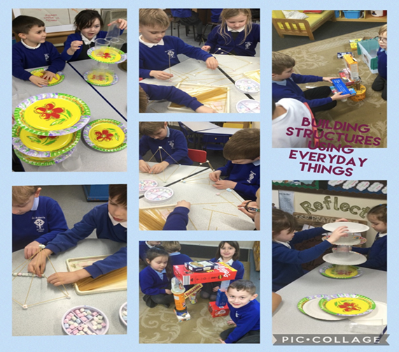

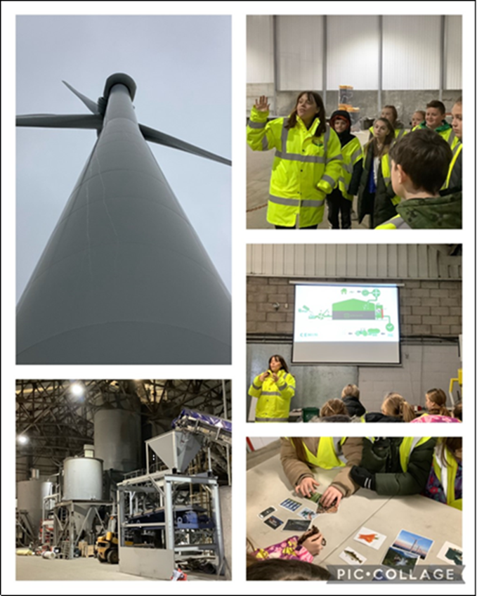
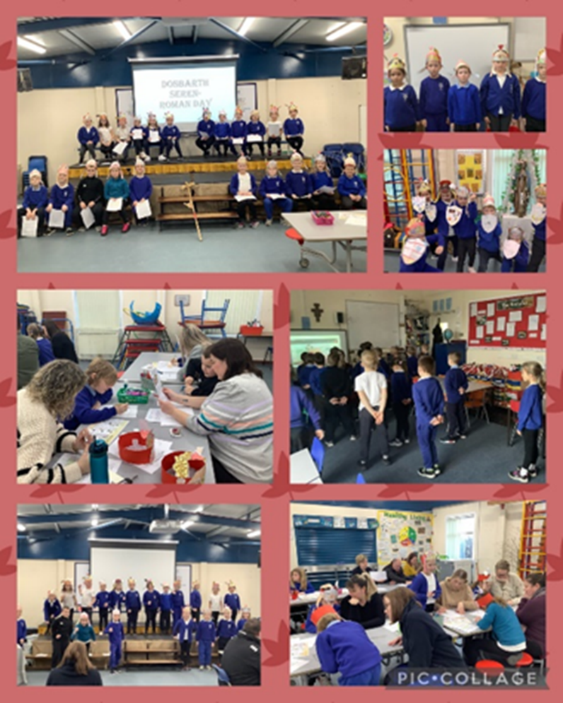

Philosophy for Children
Our children are supported in becoming effective learners through the use of Philosophy for Children (P4C). This is implemented throughout the school from Nursery to Year 6. P4C is an approach to teaching and learning that explores the big ideas that arise in all areas of education and life experience. P4C uses philosophical dialogue and enquiry to help learners to think, to speak, to listen, to learn and to live together more effectively.
P4C develops thinking skills and dispositions. P4Cs thinking model supports the development of:
- caring thinking: listening carefully, appreciating, thanking, showing interest, showing sensitivity, waiting your turn;
- collaborative thinking: responding, supporting, building on other’s ideas, inviting, sharing tasks, negotiating, joining in;
- critical thinking: questioning, reasoning, evaluating, weighing evidence, making distinctions, testing ideas, applying criteria;
- creative thinking: making connections, suggesting alternatives, giving examples, exploring possibilities, considering perspectives;
- they choose the subject matter, their voices are heard and valued in justifying their positions and listening to others, their vocabulary expands;
- they learn how to disagree respectfully, which increases their tolerance and resilience;
- they think and reflect more deeply, so their understanding improves.

This approach enables Teachers teach better because:
- they learn how to facilitate meaningful discussion;
- they develop new teaching strategies that can be used throughout their practice;
- they see students’ potential as independent thinkers by listening more, educators’ relationships with their students flourish.

Research has highlighted the positive outcomes of P4C in the following areas:
- Developments in cognitive ability;
- Developments in critical reasoning skills and dialogue in the classroom;
- Emotional and social developments.

St Robert’s has achieved the Gold Award for P4C and was the first School in Wales to obtain this. We regularly share good practise among other schools across Wales.

Curriculum Progression
Our curriculum offers appropriate progression for all our learners. It enables our learners to build connections across the six Areas of Learning and combines different experiences, knowledge, and skills. Each Area of Learning includes "What Matters Statements"; these are the curriculum's 'big ideas’ and key concepts. Our curriculum provides appropriate progression in accordance with the "Principles of Progression" from 3 to 16 years.

Curriculum Assessment
Our school's assessment arrangements are informed by the "Principles of Progression". Assessments will be completed on entry to our school, and then ongoing assessments will be embedded into daily practice and at certain points during the school year. We will use a variety of assessment evidence to enable each learner to make progress at an appropriate pace. Assessment processes will be used to identify learners who require further support or challenge. The outcome of assessments will help inform the next steps in learning for individuals and groups of learners.
Our assessment arrangements will ensure active engagement between learners and teachers and will be based on ongoing reflection of:
- Where are learners in their learning?
- Where do they need to go next?
- What do they need to get them there?
Effective progression and assessment arrangements are fundamental to achieving our school vision.

Review of the Curriculum
The school's curriculum will be reviewed to ensure that it meets the needs of learners and maintains the school's vision.
Throughout the year, various self-evaluation activities will inform our understanding of our curriculum's effectiveness. This monitoring and review process will feed into any future modifications or developments of our curriculum.
The school will continue to work across the cluster and in partnership with governors, the regional consortia, the Local Authority, and our ITE partnership to further develop a shared understanding of the progression and ensure a high-quality 3-16 continuum of learning for all.

National Reading, Numeracy & Procedural
Every year, all children in Wales from Year 2 to Year 6 will take a reading, procedural and numeracy test as part of the new National Literacy and Numeracy Framework (LNF). These usually take place in May each year. Your child must attend school during the assessment period. The school will notify parents of the assessment dates.
The main aims of these tests are to:
- Give schools an accurate gauge of individual children’s skills and abilities
- Help drive up literacy and numeracy standards in children throughout Wales
- Paint a clearer picture of how children are performing nationally

Arrangements for Complaints about the Curriculum
In the event of a complaint the procedure is as follows;
- Please speak to the class teacher. If the complaint is not resolved then please arrange an informal discussion with Headteacher, it is hoped that in most cases it can be resolved by the school.
- If the complaint can’t be resolved informally, the school’s Complaints Policy will be evoked. A copy is available on our website.

Inclusion
St Robert’s Primary School is an inclusive school that aims to meet the needs of all pupils including those with ALN. All children have access to a broad, balanced, stimulating and relevant curriculum whatever their ability or need whilst being encouraged to take responsibility for their own learning, striving to be the best they can. Multi-sensory learning and teaching approaches are used to engage and stimulate all children as learners and ensure their needs are met.

Additional Learning Needs & Education Tribunal Act (ALNET 2018)
The system for supporting children and young people with special educational needs and disability in
Wales is changing. The Welsh Government is bringing in a new more flexible and responsive system of meeting the needs of children with special educational needs or disabilities and are striving to deliver a fully inclusive education system for the learners of Wales.
The new system will ensure:
- needs are identified early, addressed quickly and all learners are supported to reach their potential.
- our professionals are skilled and confident in identifying needs and deploying strategies to help.
- learners overcome their barriers to learning.
- that the learner is at the centre of everything we do and that they and their parents and carers are equal partners in their learning. (Person Centred Approach)
- From September 2021 the new system will be brought in gradually over the next few years (2021 -2025).
Here are some of the key messages about these changes and what they may mean for you and your child.

Key Messages
The term Additional Learning Needs (ALN) will replace the terms Special Educational Needs (SEN)
and Learning Difficulties and Disabilities (LDD)
- Special Educational Needs Coordinators (SENCos) in schools will now be called Additional Learning Needs Coordinators (ALNCos)
- The mandatory ALN Code for the new system will cover children and young people aged 0-25. This means that early years and further education colleges will have duties under the Act, but this does not include higher education or apprenticeships.
- The current graduated system of Early Years/School Action, Early Years/School Action Plus and Statements is being replaced over the course of the next 3 years.
- All children and young people with an identified additional learning need (ALN) that requires additional learning provision (ALP) will have an Individual Development Plan (IDP). The IDP will replace all other individual plans.
- IDPs for children under compulsory school age, who require them, i.e.in the early years will be maintained by local authorities.
- Most Individual Development Plans will be maintained by the school but may also be maintained by the Local Authority for those learners with the most complex needs.
- The Act expects that all partners such as Education, Health and Social Care will work in collaboration to support children and young people with ALN.
- There will be increased opportunities for children, young people, parents and carers to contribute to the creation and maintenance of Individual Development Plans through Person Centred Planning.
- It is expected that working together more closely should help to avoid disagreements.
- All reasonable steps will be taken to ensure additional learning provision will be provided in Welsh, if required.

Behaviour Management
An acceptable standard of good behaviour in school, which incorporates good manners, must be actively encouraged and promoted if a school is to be a suitable place for learning to take place within a happy and secure environment. Thus, our school code contains elements to foster and monitor good manners and good behaviour. The Catholic ethos of the school should be expressed in terms of care and consideration for other members of the school community and their property.
A key element in achieving a good standard of behaviour is the example set by the Headteacher, the staff and parents.
The teachers in class deal with the majority of classroom difficulties effectively sometimes with support from the Head or Deputy Head. The school operates a positive, assertive discipline policy focussing on reward and praise and sanctions for wrong choices.

Rules
Follow the instruction the first time it is given.
To keep hands, feet and objects to ourselves.
Please keep noise level down, speak quietly and kindly at all times.
Play safely and help others.

Reward and Praise
At St. Robert’s Primary we believe that children should be encouraged to behave well and work hard. We use a number of positive consequences to do so. Whilst our aim is that children should work and behave well for the pleasure of the task, we recognise that rewards are sometimes necessary and appropriate. We use the following positive rewards: -
- Non-verbal rewards such as a thumbs up sign or a smile,
- Praise,
- Showing work to another teacher and to the headteacher,
- Stickers and star charts,
- Dojo points,
- Certificates,
- Class of the week (attendance),
- Happy note home to parents,
- Telephone calls to parents,
- Displaying work,
- Fortnightly Headteacher’s Awards & Pupil Profile Awards - mentioned in the Headteacher Newsletter
- Class Award e.g. Super Stars/Worker/Star of the week etc.

House Points System
Each child belongs to one of the following houses: St David, St Andrew, St George and St Patrick. Through living our mission statement, pupils are able to earn house points for their house. These are tallied up every fortnight and shared with pupils. At the end of every half term, the winning house receives a treat.
This system is used competitively for St David’s Day and Sports Day.

Sanctions/Consequences
The following sanction system is used throughout the school, by all staff:
- Warning given to child about their behaviour
- Name on the board
- Go to another classroom for 15 mins
- Sent to a Senior Teacher (DHT or SLT)
- Meeting arranged by Class Teacher to meet with the parents to discuss concerns
- Behaviour letter sent to parents to meet with the Headteacher & Class Teacher to discuss concerns/issues
- Severe clause (Serious Level Incident), straight to HT/SLT, all other steps missed.
Finally, the Headteacher has the right to exclude any child whose behaviour is deemed to be so bad as to be beyond the norms of childhood expectations.
Parents will always be informed by letter and also told their rights of appeal.

Wider Aspects of School Life

Pupil Voice
Our pupils are given opportunities to be involved in school decision making in a number of ways:
- Being involved in decision involving their learning e.g. topics, activities and trips.
- Being a member of the School Council, children from Yr.2 to Yr.6 select two representatives on to the School Council. They meet on a regular basis with the Deputy Head Teacher and a designated member of the Governing body. They have focused on such issues as - the School’s Anti- Bullying Policy, our Bilingualism policy, consultation on the school uniform, activities/resources for playtimes and lunchtimes, and an End of Year Pupil Questionnaire.
- The Eco Committee - representatives from Yr.2 to Yr.6 and are involved in eco projects and promotes the eco message of Reducing, Reusing and Recycling waste.
- Criw Cymraeg – promote the use of Welsh across the school.
- The Children’s Commissioner of Wales’ Super Ambassadors - two Year 6 pupils promote the rights of the Child and organise our Rights of the Child Day, leading an Assembly and organising activities for each class.
- Focus groups on particular aspects of School Life - pupils volunteer to be involved with such aspects as, our Behaviour Policy, school resources to enhance learning etc.
- Digital Leaders - to lead matters linked to digital learning: running of coding club; assistance and support with hardware.
- P4C Champions - from Yr.2 upwards - to lead with matters developing P4C throughout the school including: Listening to Learners, Organising P4C Days; Sharing P4C with stakeholders such as parents.
- St Bob’s Cogs (Our Community Out Reach Group) Yr. 3 upwards – Catholic Social Action Group. Lead by the Papal Encyclicals of Popo Francis – Laudata Si (caring for God’s creation) & Tutti Fratelli (Global Brotherhood).
- Wellbeing Warriors - two from Year 2 upwards. Improve health and wellbeing throughout the school; promote health and wellbeing in the community; passionate about sport, health, creativity and mental health; organise awareness weeks; pupil voice for wellbeing in the school and lead on wellbeing issues and targets.
- Friendship Fixers - Yr.6 - carry out peer mediation on the yard, support dinner supervisors in dealing with fallings out and friendship issues.

Healthy Schools Initiative
St Robert’s is a recognised Healthy School. We have achieved the National Quality Accreditation within the Healthy School’s Initiative and this was reaccredited in June ’22. The school develops yearly targets to improve the health of all members of the school community. You are expected to follow the school’s policy on healthy packed lunches and fruit for snacking.

Eco School
St Robert’s is a Platinum ECO school. We promote the ‘green’ message to our children: we recycle whenever possible and we work to reduce our carbon footprint. Parents will be informed of other initiatives as they occur.

Music LA Provision.
This carries no cost to parents as the school funds this. We offer string, woodwind and brass sessions provided by peripatetic teachers from Bridgend Music Service. This is offered to pupils in Upper KS 2.

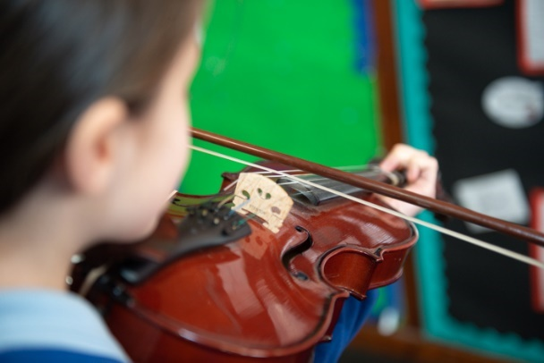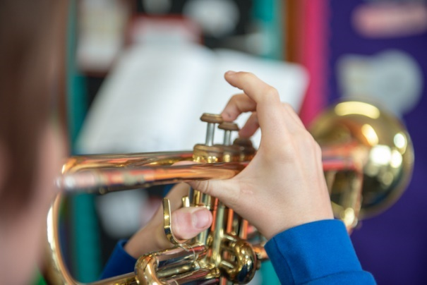
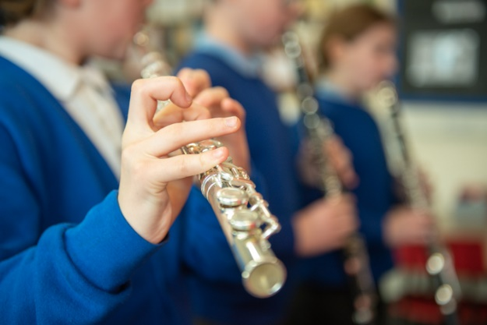

Outdoor Learning
We have beautiful grounds and a woodland area which is the habitat of many creatures and mini beasts. Our woodland walk has a pond, shrubs, wild flowers, established trees and our very own hedgehog!
We have an outdoors classroom to facilitate outdoor learning.
Children use our grounds for every aspect of the curriculum. It enhances their learning and curiosity.
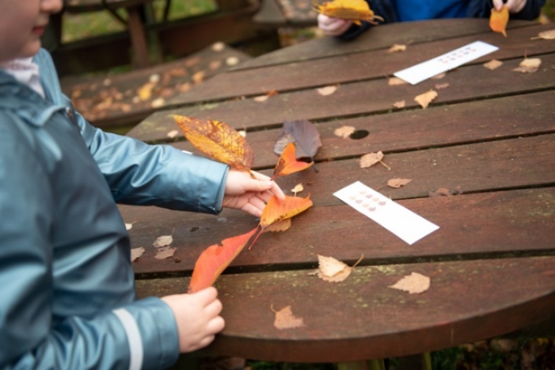
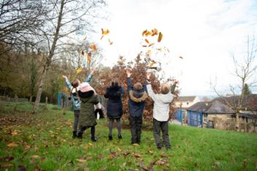
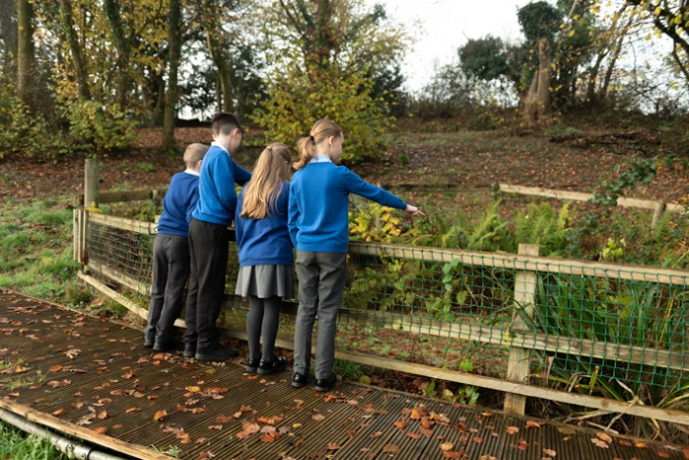

Extra-Curricular Activities
The school continually seeks to provide a range of extra-curricular activities that will enhance pupil development. These do change from time to time, according to staffing and funding streams.
The children at St. Robert’s have the opportunity to take part in a number of enjoyable and fulfilling activities throughout their time at school, these include rugby, netball, football, cricket and athletics. We also run a number of alternative activities to sport and these include a choir, craft club, recorder group, science club, cookery club, knitting club and coding club.

Educational Visits
We offer a number of trips to all classes throughout the year. These generally are linked to the topics. As we are citizens of Wales visits also enable pupils to experience all that Wales has offered (past history/geography) but modern-day Wales too.
Visits have included – St Fagan, Cardiff Museum, The Big Pit, Techniquest, Sustainable Energy, Swansea University, local train rides, Plantasia and Margam Park.
We ask parents for contributions, however if insufficient monies are collected then the visit will be cancelled. In cases of financial difficulties please contact me directly.
Residential trips- Year 6 has the opportunity to visit Llangrannog. Parents are informed of this well in advance.

Charging and Remissions
The pupils of the school make a number of educational visits related to topics being studied. It is school policy to ask for a donation from parents to cover the cost of these visits. If insufficient donations are received the visit would have to be cancelled.
Special visits e.g. from drama groups and storytellers also incur costs and donations are requested from parents to cover this.

Parent & Friends Association
The PFA’s prime functions are to raise money for the benefit of our pupils and create opportunities for us to join together as a school community. Events have included - Mother/Father’s Day Sales, Discos, Tea Parties, Raffles etc. If you would like to join the PFA please contact the school.
However, if you can’t the give time to become a member or helper please support by donating the requested items and by attending the organised events.

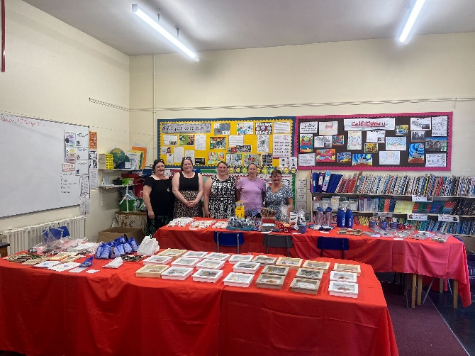

Wrap Around Care
St Robert’s is able to cater for children between 7.30am and 5.00pm.
Early Birds Club
This is provided by Simply out of School. The session runs from 7.30 -8.15 and a daily rate applies. It is fee paying. To find out more, contact Sharon: 0776980924, Email: Sharon@simplyoutofschool.co.uk or visit the website: www.simplyoutofschool.co.uk
Breakfast Club
A free Welsh Government Initiative and is available to all pupils from 8.15am, you have to register to attend, a form can be obtained from the school office.
After School Club
Simply Out of School provide an after-school club, for our pupils based at school. It is fee paying. To find out more, contact Sharon: 0776980924, Email: Sharon@simplyoutofschool.co.uk or visit the website: www.simplyoutofschool.co.uk

Equal Opportunities
At St Robert’s we are concerned with the equality of opportunity for all our children in our care. We
recognise and celebrate the fact that society is made up of people from diverse backgrounds
and life experiences. It is important that all pupils are prepared to live in such a society. The
purpose of our Strategic Equality Plan is to fulfil the duties to promote equality for people
with ‘protected characteristics’ and embed fairness and equality within our school
community and in all aspects of our school plans and policies.
We have based our Strategic Equality Objectives on local, regional and national priorities
within education as well as feedback from our school community and our own school data.
The Strategic Equality Plan can be accessed on the school website.

Admission Arrangements
We hope to admit to the school any pupils who wish to have an education based firmly on
the principles given to us by Jesus Christ. We hope that all pupils are educated in an
atmosphere of love, and learn primarily to contribute to this loving Christian atmosphere both
at school and at home.
This policy refers to admissions for the academic year 2022-23 at St. Robert’s Catholic Primary
School which is a Catholic School founded by the Church to provide education for Catholic
children. As a Voluntary Aided School, the Governing Body has sole responsibility for
admissions to the school.
The Education Act, 1980 Section 6, gives parents the right to express a preference with regard
to which school their children attend. Admission to the school will be made in accordance
with parental choice subject to the order of priority listed below.
(Please note: For each criteria, priority at St Robert’s will be given to Looked After Children
(LAC) in accordance with Section 106 of the Education Act 2005 and Education (Admission of
Looked After Children) (Wales) Regulations 2009:
The criteria for admissions are, in order of priority:
1. Looked after, baptised Catholic children.
2. Baptised Catholic children.
3. Looked after children who are baptised in another Christian denomination.
4. Children who are baptised in another Christian denomination.
5. Other looked after children.
6. Children who have siblings at the school at the time of admission.
7. Children whose parents/guardians wish them to be educated in a Christian
School and who support the Catholic ethos of the School.
In considering applications relating to these categories, a priority order may have to be
established by reference to:
• the age of any sibling in the receiving school; the youngest sibling commanding the
highest degree of priority.
• the proximity of the pupil’s home to the receiving school as measured by the shortest
practicable walking distance. The governors will use the Routefinder GIS software
system to measure all distances.
Applications from children with special needs or additional learning needs will be considered
within the context of each of the criteria and in accordance with the School’s Additional Needs
Policy.
For admission purposes a sibling is a child living at the same address who is the brother/sister,
half brother/ sister (children who share one common parent), step brother/sister where two
children are related in marriage. This definition also includes adopted or fostered children at
the same address.

The governors are responsible for all admissions to St. Robert’s. The full Admissions Policy can be found on our website www.strobertscath.co.uk

New Parents
A meeting for all new parents is held early on in the Summer Term. Arrangements are made for new children to have link up sessions during June and July.
Admission of children is staggered during the first two weeks of the Autumn Term.

School Building Fund
As St Robert’s Catholic Primary School is a Voluntary Aided School, Governors are legally responsible for 15% of all external maintenance work. The other 85 % is paid by a Welsh Government grant. All internal maintenance is paid for by Bridgend County Borough Council.
The School Building Fund was established by the school Governors to ensure that monies were available to help meet any essential external maintenance of the school that arose. A voluntary donation of £10 per term per family is recommended. Your contributions are very important.

Transition
All pupils in year six transfer to our Catholic High School, Archbishop McGrath, Bridgend. The school provides a variety of events to make transition as smooth as possible. We enjoy excellent links with the school enjoying visits from staff and pupils for a variety of activities, such as:
- An Open evening.
- A Welcome Mass
- Two transition days
- Regular Meetings with Feeder schools working on the actions identified in the Cluster’s Transition Plan.

