

St Robert’s

Foundation Phase Pupil Prayer Booklet

Sign of the Cross
In the name of the Father and of the Son and of the Holy Spirit. Amen
Yn enw’r Tad, A’r Mab, A’r Ysbryd Glan. Amen

Morning Prayer (FP)
Good morning, Lord.
We praise your Holy name.
And thank you for giving us this lovely new day.

Grace Before Meals
Bless us, O Lord, as we sit together
Bless the food we eat today,
Bless the hands that made the food,
Bless us O Lord. Amen.


Grace After Meals
Thank you, God for the food we have eaten.
Thank you, God for all our friends,
Thank you, God for everything,
Thank you, God. Amen
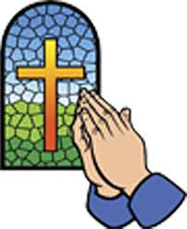

Evening Prayer
God Our Father, I come to say,
Thank you for your love today.
Thank you for my family,
and all the friends you give to me.
Guard me in the dark of night,
and in the morning send your light.
Amen.

Hail Mary
Hail, Mary, full of grace,
the Lord is with thee:
blessed art thou among women,
and blessed is the fruit of thy womb, Jesus.
Holy Mary, Mother of God,
pray for us sinners now,
and at the hour of our death.
Amen.


Our Father
Our Father who art in heaven,
hallowed be thy name.
Thy kingdom come,
Thy will be done
on earth as it is in heaven.
Give us this day our daily bread,
and forgive us our trespasses,
as we forgive those
who trespass against us.
And lead us not into temptation,
but deliver us from evil.
Amen
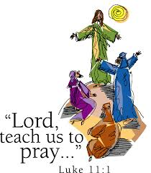

Glory be to the Father
Glory be to the Father
and to the Son
and to the Holy Spirit.
As it was in the beginning,
is now, and ever shall be,
world without end.
Amen.




Our School Prayer
Heavenly Father,
We give thanks for our school
and parish of St. Robert’s.
Bless all those who live and learn in our community.
Be near us and lead us as we learn.
Be near us and watch over us as we play.
Be near us and support us
in happy times and sad times.
Be near us and guide us when we get things right and get things wrong.
Grant us strength to face new challenges;
Grant us wisdom to know your way;
Keep us safe in your arms and give us your everlasting peace.
Amen

