

St Robert’s

Upper Junior Pupil Prayer Booklet

Sign of the Cross
In the name of the Father and of the Son and of the Holy Spirit. Amen
Yn enw’r Tad, A’r Mab, A’r Ysbryd Glan. Amen

Morning Offering (KS2)
O my God you love me,
you’re with me night and day.
I want to love you always
in all I do and say.
I’ll try to please you Father,
bless me through the day.
Amen

Grace Before Meals
Bless us, O Lord, as we sit together
Bless the food we eat today,
Bless the hands that made the food,
Bless us O Lord.
Amen

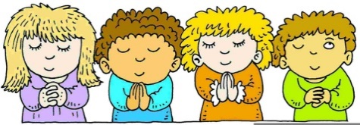
Grace After Meals
Thank you, God for the food we have eaten.
Thank you, God for all our friends,
Thank you, God for everything,
Thank you, God. Amen
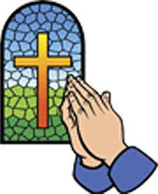

Evening Prayer
God Our Father, I come to say,
Thank you for your love today.
Thank you for my family,
and all the friends you give to me.
Guard me in the dark of night,
and in the morning send your light.
Amen.

Hail Mary
Hail, Mary, full of grace,
the Lord is with thee:
blessed art thou among women,
and blessed is the fruit of thy womb, Jesus.
Holy Mary, Mother of God,
pray for us sinners now,
and at the hour of our death.
Amen.
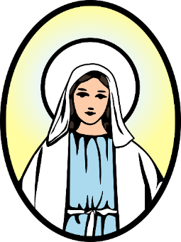

Henffych well, Fair,
gyflawn o ras, y mae’r Arglwydd gyda thi. Bendigedig wyt ti ymhlith merched,
a bendigedig yw ffrwyth dy groth di, Iesu. Sanctaidd Fair, Fam Duw,
gweddïa drosom ni bechaduriaid,
yr awr hon ac yn awr ein hangau.
Amen
Our Father
Our Father who art in heaven,
hallowed be thy name.
Thy kingdom come,
Thy will be done
on earth as it is in heaven.
Give us this day our daily bread,
and forgive us our trespasses,
as we forgive those
who trespass against us.
And lead us not into temptation,
but deliver us from evil.
Amen
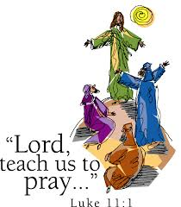

Glory be to the Father
Glory be to the Father
and to the Son
and to the Holy Spirit.
As it was in the beginning,
is now, and ever shall be,
world without end.
Amen.
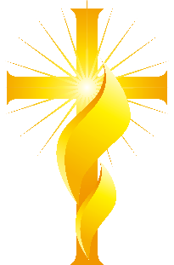

Fatima Prayer
O my Jesus, forgive us our sins,
save us from the fires of hell,
lead all souls to Heaven,
especially those most in need of
Thy mercy.
Amen

Eternal Rest
Eternal rest grant unto them, O Lord. And let perpetual light shine upon them. May they rest in peace.
Amen.

Simple Act of Contrition
O my God, I am sorry for all my sins, for not loving others and not loving you. Help me to live like Jesus and not sin again. Amen

Act of Contrition
O my God, because you are so good, I am very sorry that I have sinned against you, and with the help of your grace I will not sin again.
Amen

Angel of God
Angel of God, my guardian dear,
to whom God’s love commits me here,
ever this day be at my side,
to light and guard, to rule and guide. Amen
Come Holy Spirit
V. Come, Holy Spirit, fill the hearts of your faithful.
R. And kindle in them the fire of your love.
V. Send forth your Spirit and they shall be created.
R. And you will renew the face of the earth.
Let us pray
O God, who by the light of the Holy Spirit,
did instruct the hearts of your faithful,
grant that by that same Holy Spirit,
we may be truly wise, and ever rejoice in your consolation,
Through Christ our Lord.
Amen.

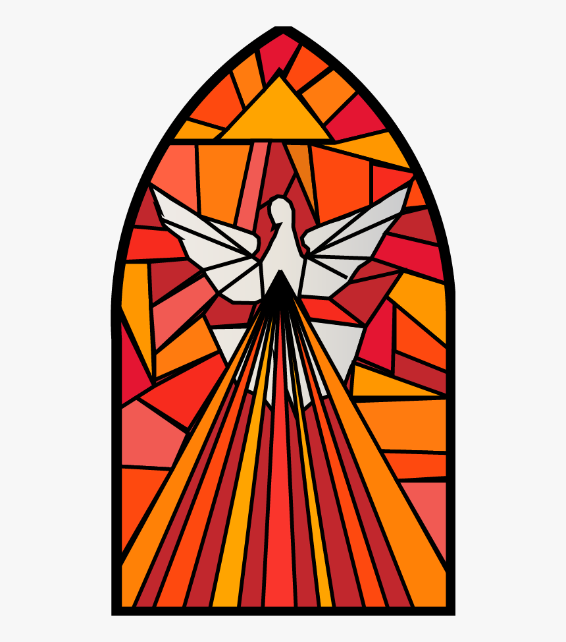

Prayer of St Richard of Chichester
Thanks be to you, my Lord Jesus Christ,
for all the benefits which you have given me,
for all the pains and insults which you have borne for me.
O most merciful Redeemer, friend and brother,
may I know you more clearly,
love you more dearly,
and follow you more nearly,
day by day.
Amen.
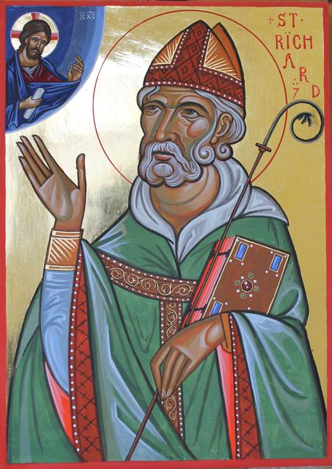

The Rosary
For each mystery or decade, one Our Father, ten Hail Marys and the Glory be is recited.
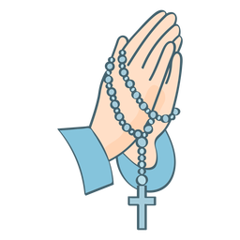

Joyful Mysteries (Monday and Saturday)
The Annunciation (Luke 1:26–38)
The Visitation (Luke 1:39–45)
The Nativity (Luke 2:1–7)
The Presentation in the Temple (Luke 2:22–35)
The Finding in the Temple (Luke 2:41–52)

Mysteries of Light (Thursday)
The Baptism of Jesus (Matthew 3:13–17)
The Wedding Feast of Cana (John 2:1–12)
The Proclamation of the Kingdom, with the call to Conversion (Mark 1:14–15; 2:3–12)
The Transfiguration (Luke 9:28–36)
The Institution of the Eucharist (Matthew 26:26–29)

Sorrowful Mysteries (Tuesday and Friday)
The Agony in the Garden (Mark 14:32–42)
The Scourging at the Pillar (Matthew 27:15–26)
The Crowning with Thorns (Matthew 27:27–31)
The Carrying of the Cross (John 19:15–17; Luke 23:27–32)
The Crucifixion (Luke 23:33–38, 44–46)

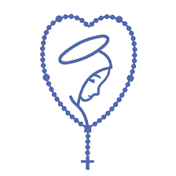

Glorious Mysteries (Wednesday and Sunday)
The Resurrection (Matthew 28:1–8)
The Ascension (Acts 1:6–11)
The Descent of the Holy Spirit (Acts 2:1–12)
The Assumption (1 Thessalonians 4:13–19)
The Coronation of Mary Queen of Heaven and Earth (Revelation 12:1; 14:1–5; Isaiah 6:1–3)

Hail, Holy Queen
Hail, holy Queen, mother of mercy;
hail, our life, our sweetness and our hope!
To thee do we cry,
poor banished children of Eve;
To thee do we send up our sighs mourning and weeping in this vale of tears.
Turn then, most gracious advocate,
thine eyes of mercy towards us; and after this our exile, show unto us the
blessed fruit of thy womb, Jesus.
O clement, O loving, O sweet Virgin Mary.
Pray for us, O holy Mother of God.
that we may be made worthy of the promises of Christ.
Let us pray.
O God, whose only-begotten Son,
by his life, death and resurrection,
has purchased for us the rewards of eternal life,
grant, we beseech thee, that meditating on these mysteries of the most holy Rosary of the Blessed Virgin Mary,
we may imitate what they contain
and obtain what they promise,
through the same Christ our Lord. Amen
The Magnificat
My soul proclaims the greatness of the Lord,
and my spirit rejoices in God my Saviour,
for he has looked upon his handmaid in her lowliness;
for behold, from this day forward,
all generations will call me blessed.
For the Almighty has done great things for me,
and holy is his name.
His mercy is from age to age
for those who fear him.
He has made known the strength of his arm,
and has scattered the proud in their conceit of heart.
He has cast down the mighty from their thrones
and has exalted those who are lowly.
He has filled the hungry with good things,
and has sent the rich away empty.
He has helped his servant Israel,
mindful of his mercy,
even as he promised to our fathers,
to Abraham and his descendants for ever.
Glory be to the Father and to the Son
and to the Holy Spirit,
as it was in the beginning, is now,
and ever shall be, world without end.
Amen.

Mary’s song of praise was first sung to her cousin Elizabeth
(Luke 1:46–55).
It is sung daily at Evening Prayer.

Act of Faith
My God, I believe in you
and all that your Church teaches,
because you have said it,
and your word is true.

Act of Hope
My God, I hope in you,
for grace and for glory,
because of your promises,
your mercy and your power.

Act of Love
My God, because you are so good,
I love you with all my heart,
and for your sake,
I love your neighbour as myself.
The Angelus
V. The Angel of the Lord declared unto Mary.
R. And she conceived of the Holy Spirit.
Hail, Mary, full of grace, the Lord is with thee.
Blessed art thou among women,
and blessed is the fruit of thy womb, Jesus.
Holy Mary, Mother of God,
pray for us sinners,
now and at the hour of our death.
Amen.
V. Behold the handmaid of the Lord.
R. Be it done unto me according to thy word. Hail Mary…
V. And the Word was made flesh.
R. And dwelt among us. Hail Mary…
V. Pray for us, O holy Mother of God.
R. That we may be made worthy of the promises of Christ.
Let us pray;
Pour forth, we beseech thee, O Lord,
thy grace into our hearts;
that we, to whom the Incarnation of Christ, thy Son,
was made known by the message of an angel,
may by his Passion and Cross be brought to the glory of his Resurrection.
Through the same Christ, our Lord. Amen.

Apostles’ Creed
I believe in God,
the Father almighty
Creator of heaven and earth,
and in Jesus Christ, his only Son, our Lord,
At the words that follow, up to and including the Virgin Mary, all bow.
who was conceived by the Holy Spirit,
born of the Virgin Mary,
suffered under Pontius Pilate,
was crucified, died and was buried;
he descended into hell;
on the third day he rose again from the dead;
he ascended into heaven,
and is seated at the right hand of God the Father almighty;
from there he will come to judge the living and the dead.
I believe in the Holy Spirit,
the holy catholic Church,
the communion of saints,
the forgiveness of sins,
the resurrection of the body,
and life everlasting. Amen
Nicene Creed
I believe in one God,
the Father almighty,
maker of heaven and earth,
of all things visible and invisible.
I believe in one Lord Jesus Christ,
the only Begotten Son of God,
born of the Father before all ages.
God from God, Light from Light,
true God from true God,
begotten, not made, consubstantial with the Father;
through him all things were made.
For us men and for our salvation
he came down from heaven,
and by the Holy Spirit was incarnate of the Virgin Mary, (all bow)
and became man.
For our sake he was crucified under Pontius Pilate,
He suffered death and was buried;
and rose again on the third day in accordance with the scriptures;
He ascended into heaven
and is seated at the right hand of the Father.
He will come again in glory to judge the living and the dead,
and his kingdom will have no end.
I believe in the Holy Spirit, the Lord, the giver of life,
who proceeds from the Father and the Son,
who with the Father and the Son is adored and glorified,
who has spoken through the Prophets.
I believe in one, Holy, Catholic and Apostolic Church.
I confess one Baptism for the forgiveness of sins
And I look forward to the resurrection of the dead,
and the life of the world to come.
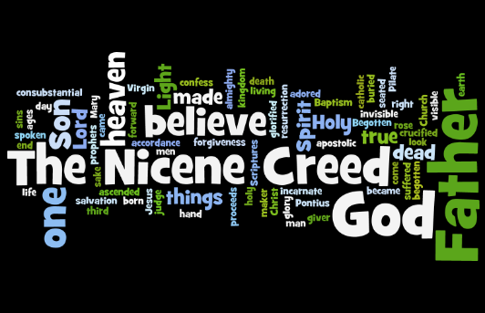
Amen.


Our School Prayer
Heavenly Father,
We give thanks for our school
and parish of St. Robert’s.
Bless all those who live and learn in our community.
Be near us and lead us as we learn.
Be near us and watch over us as we play.
Be near us and support us
in happy times and sad times.
Be near us and guide us when we get things right and get things wrong.
Grant us strength to face new challenges;
Grant us wisdom to know your way;
Keep us safe in your arms and give us your everlasting peace.
Amen

